Before

* Informed consent
* MRI screening = pregnant, metal, implant, epilepsy, claustrophobia
* Remove = metal, electronics, wallet and cb, keys…

Setup

* Headcoil imp to send radiofrequency pulse
* Padding for comfort and block move
* Cushion under their legs (TELL THEM NO CROSS)
* Buttonbox
* Padding on top of head to block noise
* (then mirror?)
* Emergency squeeze ball
* Pads under arms
* Go in

Sequence

* Localizer of the head
* High resolution anatomical scan
* SELECT FIELD OF VIEW OF FUNCTIONAL SCAN

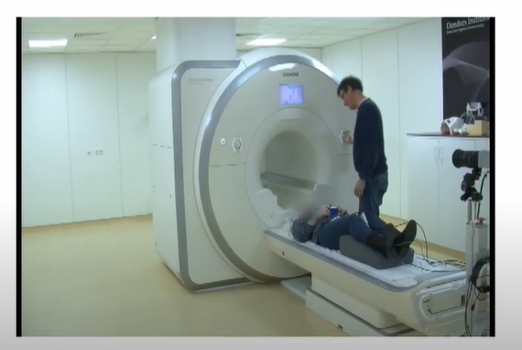

MANUAL

* 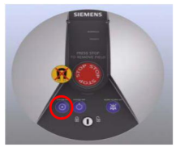turn on button, not sure if necessary, takes 15min, 3 beeps when done

How to test stimuli/task with phantom

* 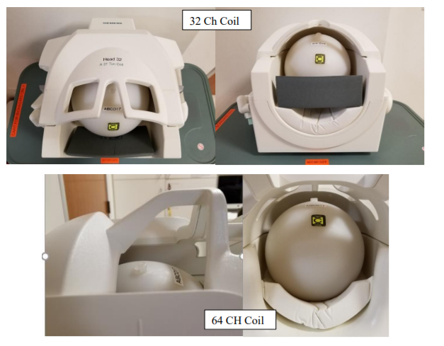
* Register
  + Press little person key on keyboard
  + Patient info = name, id, sex, age, height, weight, referring physician, position (head first supine)
  + Click exam
    - Choose sequence of choice
    - Click confirm
* Scan
  + Press green play button to start localizer
    - Seq3 snr map = Center the yellow box on head/phantom (place it right through the cap (red circle) and press green button
    - 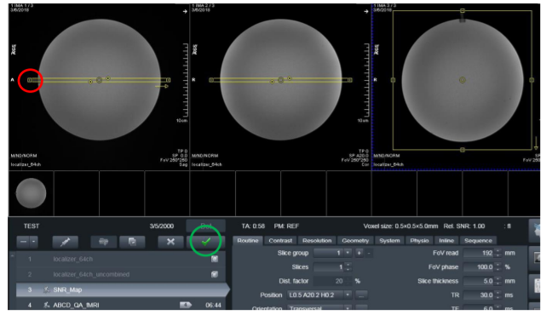
    - Seq4 same
    - Press ok to warning after 3 runs

Quality insurance

Button box 33

Positioning the participant 41-47